Software Requirements Specification

Project Name: RecipeHolder

Company/Organization: N/A

Version 2.0

Date 12/2/12

Author(s): Andy Churchill

Modification History

Version | Date | Changes | Author
1.0 | 6/29/12 | Initial Draft | Andy Churchill
2.0 | 12/2/12 | Revised | Andy Churchill

Document Approvals

Name | Role | Signature

1 Introduction
1.1 Purpose
  - Project Scope
1.3 Definitions, Acronyms, Abbreviations
1.4 References
2 System Description
3 Functional Requirements
3.1 System Features
3.1.1 System Features 1
3.1.2 System Features 2
3.2 Use Cases
3.2.1 Use Case Diagrams
3.2.2 Use Case 1
3.2.3 Use Case 2
3.3 Entity Relationship Diagrams
3.4 Data Dictionary
3.4.1 Entity 1
3.4.2 Entity 1
4 External Interface Requirements
5 Technical Requirements (Non Functional)
5.1 Performance
5.2 Scalability
5.3 Security
5.4 Maintainability
5.5 Usability
5.6 Multilingual Support
5.7 Auditing and Logging
5.8 Availability
6 Open Issues
7 Appendix
8 Interview Questions
9 Future Ideas
9.1 Add Software Accessibility
9.2 Tool Tips
9.3 Add Printing Capabilities
9.4 Add Form to Allow User to Make New Password

1 Introduction

Purpose
This document presents a detailed description of the RecipeHolder System. It will explain the features, and the requirements, both functional and non-functional .The targeted audience is anyone that wants to save cooking recipes in a centralized place.

1.2 Project Scope
The RecipeHolder software system is designed for people that are in need of a centralized location for cooking recipes. These recipes hold nutrition details, ingredients, preparation and baking instructions. Users can add, update, and delete their recipes from their own personal database.

Definitions, Acronyms, Abbreviations
SRS – Software Requirements Specification

References
N/A

System Description
The RecipeHolder System will be installed on a desktop computer. A user must log in with a recipe profile or a username, password and a recipe profile. From there a user can choose to add, update, delete or view any recipes they desire. User can also add ingredients to their own personal ingredient database.

3 Functional Requirements

3.1 Logging In / Creating an Account
3.1.1.1 Log-On Form: If the user’s choice is Create Account, the Create Account Form should show
3.1.1.2 Log-On Form: If the user chooses the Choose Profile option then the Profile Overview Form should show.
3.1.1.3 Log-On Form: If the user chooses entering a valid username and password, the Recipe Overview Form shows.
3.1.2.1 Create Account Form: User chooses between two types of accounts, recipe profile or a username, password account.
3.1.2.2 Create Account Form: The user may check a checkbox to enable the username and password fields. If user leaves the checkbox blank, then the user chooses a recipe profile.
3.1.2.3 Create Account Form: When the user accepts the information entered, the Recipe Overview Form will Show.
3.1.3.1 Profile Overview Form: Should have the name of the profile, date created, and user’s name fields present on the form.
3.1.3.2 Profile Overview Form: When the user selects a profile, the Recipe Overview Form shows.

(Use Case 100)
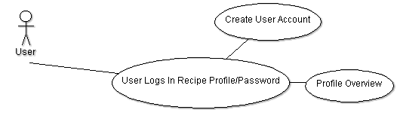
ID | 100
Description | User has three choices, log in, create an account or to log in with the profile overview. If the user is successful in logging-on to his/her account, the main form will be shown.
Trigger | User starts up the program after installing the RecipeHolder System.
Preconditions | User must have the RecipeHolder System installed on their computer.
Basic Steps | - User is presented with the Log-On Form.  - If user chooses to log-on with a password, if successful, the Recipe Overview Form shall be displayed. If not successful then an error message is displayed.  - If the user clicks the Choose Profile link button, the user is presented with the Profile Overview Form. If there are no profiles, the user will be presented with an error message. If the user has profiles to choose from, the user clicks on a profile and then the Recipe Overview Form will be shown.  - If the user chooses to click the Create Account link button, the Create Account Form will show. If the user checks the Protect Account with Password checkbox, then the user must enter his/her first name, last name, user name, and the password to the account. If the user leaves the Protect Account with Password checkbox unchecked, the user needs only to enter his/her first and last name.
Alternate Steps | User may terminate the program from the log-in form.
Exceptions | N/A
Business validations/Rules | If the user enters an empty username or password then the user will be presented with an error message.  -If the user enters an invalid user name, or password, then the user will be presented with an error message.  -If the user chooses the Choose Profile link button and there are no profiles created in the database, the user will be presented with an create new profile screen.  -If the user checks the Protect Account with Password checkbox, the user must enter all fields or be presented with an error message.  -If the user leaves the Protect Account with Password checkbox unchecked, the user name and password fields will be disabled.
Post conditions | Either an account is created and the user is logged-on or the user is successful in logging-on. Either way the main form, Recipe Overview will be shown.

3.2 Main Form
3.2.1.1 Recipe Overview Form: Users shall be able to view all recipes in the database.
3.2.1.2 Recipe Overview Form: Users shall be able to search for recipes on the criteria in a recipe.
3.2.1.3 Recipe Overview Form: When the recipe viewer button is clicked, the Recipe Viewer Form should show.
3.2.1.4 Recipe Overview Form: Users shall be able to navigate the recipe database.
3.2.1.5 Recipe Overview Form: When the edit recipe button is clicked, the Edit Recipe Form should show with the recipe data to edit.
3.2.1.6 Recipe Overview Form: If the add recipe button is clicked, the Add Recipe Form shows.
3.2.1.7 Recipe Overview Form: Users shall be able to delete a recipe.
3.2.1.8 Recipe Overview Form: When the form is loaded, the datagridview will be loaded with recipes from a database if the database has any records in it.
3.2.2.1 Recipe Viewer Form: Users shall be able to view the current recipe in printable format.
3.2.2.2 Recipe Viewer Form: Users shall be able to print the current recipe.
3.2.2.3 Recipe Viewer Form: Users shall be able to navigate the recipe database from this view.
3.2.2.4 Recipe Viewer Form: The user should be able to send the recipe by e-mail.
3.2.3.1 Edit Recipe Form: Users shall have the option of updating, deleting, or adding a recipe.
3.2.4.1 Add Ingredient Types Form: Users shall have the option of adding, updating, editing and deleting an ingredient.
3.2.4.2 Add Ingredient Types Form: Users shall have the option of adding, updating, editing and deleting a course type.
3.2.4.3 Add Ingredient Types Form: Users shall have the option of adding, updating, editing and deleting a food type.
3.2.4.4 Add Ingredient Types Form: Users shall have the option of adding, updating, editing and deleting a cuisine type.
3.2.4.5 Add Ingredient Types Form: Users shall have the option of adding, updating, editing and deleting a unit measurement type.

(Use Case 200)

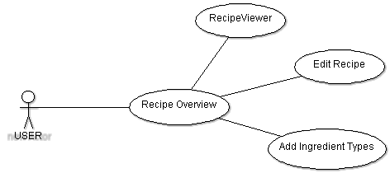

ID | 200
Description | User is on the Recipe Overview Form. User has the ability edit, delete, search and view recipes on the Recipe Overview Form. User also has the ability to add, update, delete, ingredients, courses, unit measurements, food type, and cuisines.
Trigger | User clicks the ok button and chooses profile or creates account to log-in. Recipe Overview Form shows.
Preconditions | User must be logged-on with either a recipe profile account, or a password protected account.
Basic Steps | - User is presented with the Recipe Overview Screen. From there the user can choose to edit a recipe, delete a recipe, search a recipe, add ingredient types, or view a recipe in a recipe viewer.  - If user chooses to edit recipe, an edit form will appear with the selected recipe to edit.  - If the user chooses to add ingredient types, the user is presented with the Ingredient Types Form. From there the user can add, update, delete or view the cuisine types, course types, ingredients, and unit measurements.  - Recipe Viewer Form can be accessed from the menu or from a button on the Recipe Overview Form. The recipe viewer shows how the recipe will look when printed out.
Alternate Steps | N/A
Exceptions | N/A
Business validations/Rules | -If there are recipes currently in the datagridview, the delete button will be enabled.  -If there are no recipes in the datagridview either from a search or no files in the database, then the delete button will be disabled.  -If there are any recipes in the datagridview, then there should always be one recipe selected at all times.  -When the user navigates between records, the number of records textbox should reflect how many records there are. The record number the user is currently on should also be updated.  -If the user deletes a record, the total number of records and what record the user is on should be updated.  -Any fields marked as necessary in the Add Ingredient Types form needs to be filled out when saving or the user will be presented with an error message.  -The database will check to see if any recipe, ingredient, course type, cuisine type, unit measurement, or food type is unique. The user will be prompted to overwrite or change the name.
Post conditions | A recipe deleted, a recipe searched, or a recipe updated. Possibility of the Recipe Viewer, Edit Recipe, or Add Ingredient Types forms are shown.

3.3 Add Recipe/ Unit Converter/ Edit Account
3.3.1.1 Add Recipe Form: Users shall be able to add a new recipe to the recipe table.
3.3.2.2 Edit Account Form: Users shall be able to go between a password protected account to one that is not protected by password.
3.3.3.1 Edit Account Form: Users shall be able to edit any account information in their profile.

(Use Case 300)
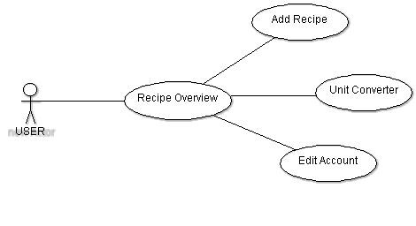

ID | 300
Description | User is on the Recipe Overview Form. User has the ability add a new recipe, edit their account or view conversions between different units of measurements for cooking.
Trigger | User clicks the ok button and chooses profile or creates account to log-in. Recipe Overview Form shows.
Preconditions | User must be logged-on with either a recipe profile account, or a password protected account.
Basic Steps | - User is presented with the Recipe Overview Screen. From there user can choose to add a recipe, edit an account or view the unit converter.  - If the user chooses to edit a recipe then Edit Recipe Form will show. User edits the data and clicks save button to save the update to the database.  - If user chooses to add a new recipe, then the Add Recipe Form will show. User enters new data and then clicks the save button to save to the database.  - User can choose to show the Unit Converter Form. The Unit Converter Form will show where the user can convert from one cooking measurement to another.
Alternate Steps | N/A
Exceptions | N/A
Business validations/Rules | -Any fields marked as necessary in the Add Recipe Form needs to be filled out when saving or the user will be presented with an error message.  -When saving a recipe, the database will check to see if there is any other recipe with the same name. If there is a recipe with the same name, then the user will be prompted to overwrite the previous recipe or change the name.
Post conditions | A new recipe is added. Account is updated. Unit Converter form is shown.

4 External Interface Requirements
None

5 Non-Functional Requirements
5.1.1.1: User should experience no delay when adding, editing updating, deleting, or searching for recipes.
5.1.1.2:
5.1 Performance
<For example, what is the response time required?>
5.2 Scalability
Single User Program
5.3 Security
Users can choose between password protecting their account and having no password to protect it.
5.4 Maintainability

5.6 Usability

5.7 Multi lingual Support
English language

5.8 Auditing and Logging

5.9 Availability
N/A
6 System Evolution
Requirement | NEEDED
3.1.1.1 Log-On Form: If the user’s choice is Create Account, the Create Account Form should show | Essential
3.1.1.2 Log-On Form: If the user chooses the Choose Profile option then the Profile Overview Form should show. | Essential
3.1.1.3 Log-On Form: If the user chooses entering a valid username and password, the Recipe Overview Form shows. | Essential
3.1.2.1 Create Account Form: User chooses between two types of accounts, recipe profile or a username, password account. | Essential
3.1.2.2 Create Account Form: The user may check a checkbox to enable the username and password fields. If user leaves the checkbox blank, then the user chooses a recipe profile. | Essential
3.1.2.3 Create Account Form: When the user accepts the information entered, the Recipe Overview Form will Show. | Essential
3.1.3.1 Profile Overview Form: Should have the name of the profile, date created, and user’s name fields present on the form. | Essential
3.1.3.2 Profile Overview Form: When the user selects a profile, the Recipe Overview Form shows. | Essential
3.2.1.1 Recipe Overview Form: Users shall be able to view all recipes in the database. | Essential
3.2.1.2 Recipe Overview Form: Users shall be able to search for recipes on the criteria in a recipe. | Essential
3.2.1.3 Recipe Overview Form: When the recipe viewer button is clicked, the Recipe Viewer Form should show. | Essential
3.2.1.4 Recipe Overview Form: Users shall be able to navigate the recipe database. | Essential
3.2.1.5 Recipe Overview Form: When the edit recipe button is clicked, the Edit Recipe Form should show with the recipe data to edit. | Essential
3.2.1.6 Recipe Overview Form: If the add recipe button is clicked, the Add Recipe Form shows. | Essential
3.2.1.7 Recipe Overview Form: Users shall be able to delete a recipe. | Essential
3.2.1.8 Recipe Overview Form: When the form is loaded, the datagridview will be loaded with recipes from a database if the database has any records in it. | Essential
3.2.2.1 Recipe Viewer Form: Users shall be able to view the current recipe in printable format. | Desirable
3.2.2.2 Recipe Viewer Form: Users shall be able to print the current recipe. | Essential
3.2.2.3 Recipe Viewer Form: Users shall be able to navigate the recipe database from this view. | Desirable
3.2.2.4 Recipe Viewer Form: The user should be able to send the recipe by e-mail. | Optional
3.2.3.1 Edit Recipe Form: Users shall have the option of updating, deleting, or adding a recipe. | Essential
3.2.4.1 Add Ingredient Types Form: Users shall have the option of adding, updating, editing and deleting an ingredient. | Essential
3.2.4.2 Add Ingredient Types Form: Users shall have the option of adding, updating, editing and deleting a course type. | Essential
3.2.4.3 Add Ingredient Types Form: Users shall have the option of adding, updating, editing and deleting a food type. | Essential
3.2.4.4 Add Ingredient Types Form: Users shall have the option of adding, updating, editing and deleting a cuisine type. | Essential
3.2.4.5 Add Ingredient Types Form: Users shall have the option of adding, updating, editing and deleting a unit measurement type. | Essential
3.3.1.1 Add Recipe Form: Users shall be able to add a new recipe to the recipe table. | Essential
3.3.2.1 Unit Converter Form: Users shall be able to convert from one unit of measurement to another unit of measurement. | Desirable
3.3.3.1 Edit Account Form: Users shall be able to edit any account information in their profile. | Essential
3.3.3.2 Edit Account Form: Users shall be able to go between a password protected account to one that is not protected by password. | Essential

6 Open Issues
N/A

7 Appendix A: Use Case
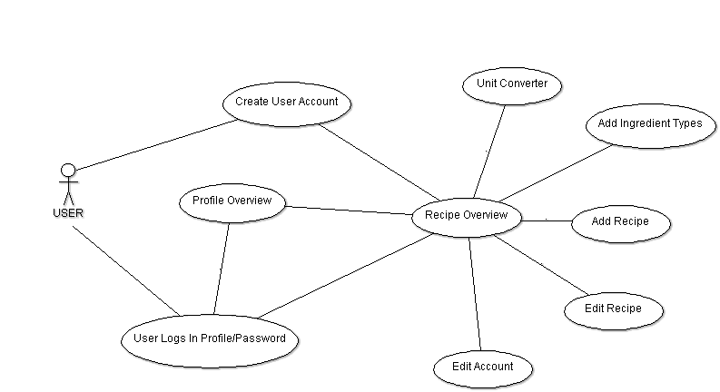

8 Interview Questions

N/A

9 Future Ideas
9.1 Add Software Accessibility
Allow keyboard shortcuts, Mouse Keys, and Object information. Allow selection of different font sizes, font color, font types and backgrounds. Audio alerts, volume control, video and text representation.
9.2 Tool Tips
Add tool tips to controls that need them.
9.3 Add Printing Capabilities
Add printing to information forms.
9.4 Add Form to Allow User to Make New Password
Allow a user to create a new password.
9.5 Add a Delete Account Option
Allow a user to delete his/her account.

